Primary Care Experience
The US health care design has shaped very different primary care over the last decades in areas such as primary care experience. This is primarily due to new sources of primary care such as nurse practitioners and physician assistants and due to ever lower levels of retention in primary care across all sources.
Least experienced graduates could present a problem in front line careers such as primary care, urgent care, retail care and emergency care where the range of presentations can be significant in severity and in complexity.
But there is very little research done regarding the impact of experience or inexperience. In fact there is little that even mentions the lack of experience.
The massive expansions of graduates produce many more with low or no experience. For example about 40,000 nurse practitioner graduates enter practice with no NP experience. They enter a workforce of about 350,000. This roughly translates to 12% with no experience and could reach 50% with less than 5 years of experience.
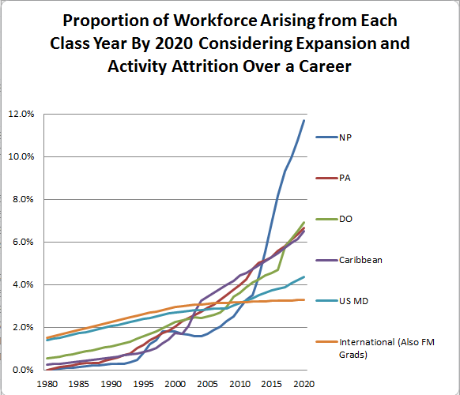

Primary care experience is my great concern. Nurse practitioners have many characteristics to consider with regard to less experience.
- Massive expansion
- Lowest activity in practice at 60% compared to 80% for physicians and physician assistants
- Most churn between specialties
- Departure from practices
- Lower volume of primary care by 10 – 20%
- Departures from primary care, taking their experience out of the remaining primary care pool
- Fewest years in a career by 8 to 10 years (narrowing with earlier entry but some loss of RN experience prior to NP)
Physician and physician assistant graduates also are impacted by rapid expansion and departures from primary care, but have less impact compared to NP. Nurse practitioners and physician assistants may also have roles that have less autonomy, although this is changing.
All sources have been focused more upon micromanagement, metrics, measurements, and electronic records. This can limit volume and interactions important for patient care experience development.
Measures of experience levels can help illustrate the problems of massive expansions and the weak financial design for primary care. The need for better funding to support retention in primary care and in the same locations in practices would be illustrated. Also the sources of workforce may want to reconsider such rapid expansion because of
- Lower levels of experience
- Expansions at 6 to 10 times faster than population growth
- Expansions at 3 to 5 times faster than demand or faster than dollars going to these health professionals
- Fewer, larger, and more powerful health care employers that could be more abusive with too many graduates
- Rapidly rising health care costs in the procedural, technical, subspecialized, and hospital areas most favored by the financial design
- The inability of massive expansions to resolve deficits such as half enough generalists and general specialists for half of the US population.
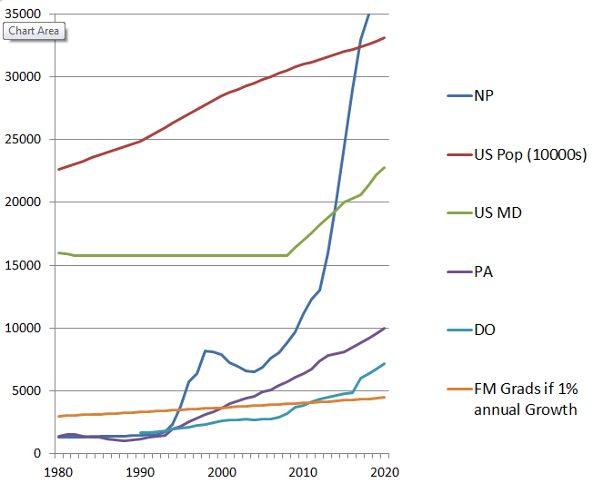
One problem with studies of experience as far as impacts upon outcomes is that outcomes are difficult to measure. It is very difficult to separate patient populations and characteristics from outcomes. Classic examples are studies of NP vs MD which tend to indicate the same outcomes when the populations studied are same or similar. Resident work hours studies involving the same populations compared before and after indicate the same outcomes. In contrast rural vs urban, low vs high volume, and other studies favor the populations with inherently better outcomes.
There is the constant question to address. Are we better by focusing on providers to change outcomes or does this require long term changes in the populations – difficult or impossible for short term encounters to shape.
For example the population in 2621 counties lowest in health care workforces has concentrations of elderly, poor, disabled, and those with lower levels of social determinants and health literacy. They have concentrations of the worst morbidity, mortality, longevity, and premature death to go with lowest levels of workforce, access to care, and social supports.
Readmission penalties of 1 to 2% in year 2 were seen in 3 % of urban hospitals, 5% overall, 9% of rural hospitals, and 14% of the remaining hospitals in 2621 counties lowest in health care workforce.
Primary care may suffer the worst from lack of experience due to the financial design. This shapes flat lined primary care and the lesser design may send primary care team members away from primary care. This would be a problem for primary care experience.
In CHCs and in worst funded primary care settings, there can be higher turnover and more with inexperience. Indeed this may be true whenever a practice faces higher concentrations of Medicaid and other worst plans.

The financial design indicators are flat lined primary care workforce and primary care spending. There may be worsening where care is already most compromised in revenue and in additional costs of delivery. 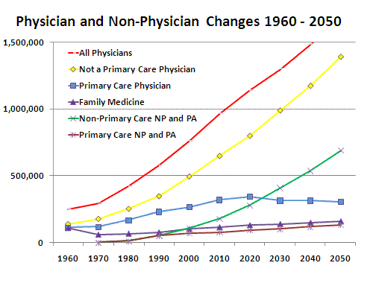

Medicare 2011 data demonstrates lower payments for office services in the counties lowest in health care workforce. These states and counties have the worst Medicare plans and likely have the worst Medicaid and private plans. Concentrations of elderly, poor, disabled, and worst employers will tend to shape deficits of workforce.
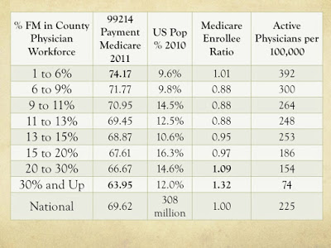

I estimate about 38 billion in primary care spending for these counties or less than 20% of primary care spending. These 2621 counties most behind have 25% of the primary care workforce in 40% of the population. Arguably 45% of the patient complexity is packed into these counties.

A return to designs that support local health care and delivery team members seems to be in order.
A much better financial design should also result in better continuity and better primary care experience in the delivery team members.

Robert C. Bowman, MD
30 years of teaching, delivering, and researching Basic Health Access
Databases including numerous county and workforce characteristics from the County Rankings, Area Resource File, and AMA Masterfile

