It is very common for experts to promote higher functioning or patient centered primary care. They discuss integration, coordination, and outreach. But what is the situation in 2621 counties lowest in health care workforce with half enough primary care, women's health, and mental health?
It appears that there is a lack of awareness regarding half enough generalists and general specialists for half the nation’s population.
I am concerned as these deficits are seen
1. where American is growing fastest in population numbers, demand, and complexity
2. where the worst Medicaid, Medicare, and private health plans are concentrated 3. where the worst employers are concentrated with their worst paychecks, benefits, and health insurance plans
4. where practices and hospitals are being closed and compromised and local health care leadership is being run off
5. where cost cutting designs or Type 1 micromanagement has been punishing those smaller and most vulnerable since the 1980s - while not saving health care costs
6. where quality improvement or Type 2 micromanagement (digitalization, regulation, innovation, rearrangement) has failed to improve outcomes which are about populations, not providers, but this has increased costs of delivery, compromised providers, and impaired those who deliver the care
7. where training interventions such as new types of health professionals or expansions of NP PA DO and MD have apparently failed to resolve deficits and access barriers despite decades of class years of overexpansions
8. where demand continues to increases the most and supply decreases the most
9. where practices and hospitals are paid 15 - 30% less despite increasing costs of delivering care and ever higher complexity of patients and care delivery
10. where outcomes are consistently worse due to worst social determinants, social supports, environments, conditions, behaviors, employers, situation
These 2621 counties have long had deficits of workforce but also represent lower indicators across many other health, behavior, workforce, social determinant, and support areas.
The financial design indicators are flat lined primary care workforce and primary care spending. There may be worsening where care is already most compromised in revenue and in additional costs of delivery. 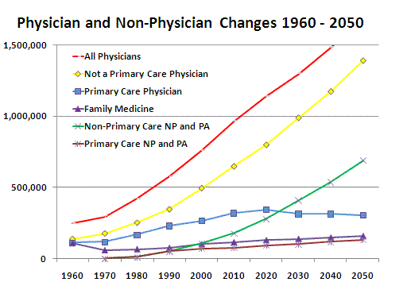

Medicare 2011 data demonstrates lower payments for office services in the counties lowest in health care workforce. These states and counties have the worst Medicare plans and likely have the worst Medicaid and private plans. Concentrations of elderly, poor, disabled, and worst employers will tend to shape deficits of workforce.
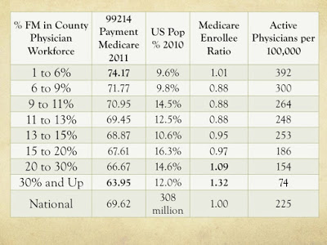

I estimate about 38 billion in primary care spending for these counties or less than 20% of primary care spending. These 2621 counties most behind have 25% of the primary care workforce in 40% of the population. Arguably 45% of the patient complexity is packed into these counties.
When working with Nebraska rural managed care, it was clear that the local plans were not a good fit with local workforce. SERPA/RCCN learned to work with local employers, benefit managers, hospitals, workers compensation, and more to protect local health access and local populations.
A return to designs that support local health care and delivery team members seems to be in order.
Robert C. Bowman, MD
30 years of teaching, delivering, and researching Basic Health Access
Databases including numerous county and workforce characteristics from the County Rankings, Area Resource File, and AMA Masterfile

