As a Researcher focused upon Basic Health Access, I am concerned with the health care design. It appears that there is a lack of awareness regarding half enough generalists and general specialists for half the nation’s population.

I am concerned as these deficits are seen  
1. where American is growing fastest in population numbers, demand, and complexity  
2. where the worst Medicaid, Medicare, and private health plans are concentrated 3. where the worst employers are concentrated with their worst paychecks, benefits, and health insurance plans  
4. where practices and hospitals are being closed and compromised and local health care leadership is being run off  
5. where cost cutting designs or Type 1 micromanagement has been punishing those smaller and most vulnerable since the 1980s - while not saving health care costs  
6. where quality improvement or Type 2 micromanagement (digitalization, regulation, innovation, rearrangement) has failed to improve outcomes which are about populations, not providers, but this has increased costs of delivery, compromised providers, and impaired those who deliver the care  
7. where training interventions such as new types of health professionals or expansions of NP PA DO and MD have apparently failed to resolve deficits and access barriers despite decades of class years of overexpansions  
8. where demand continues to increases the most and supply decreases the most  
9. where practices and hospitals are paid 15 - 30% less despite increasing costs of delivering care and ever higher complexity of patients and care delivery  
10. where outcomes are consistently worse due to worst social determinants, social supports, environments, conditions, behaviors, employers, situation

Physician Distribution By Concentration coding

The nation was divided into a top 10% of the population in top concentrations of workforce, a higher 20%, a middle 30%, and a lowest 40% in 2621 counties. This was done by stacking counties according to concentrations of physicians. This raw result was smoothed for adjacency to reflect transportation difficulties and the need for local access to generalists and general specialists.

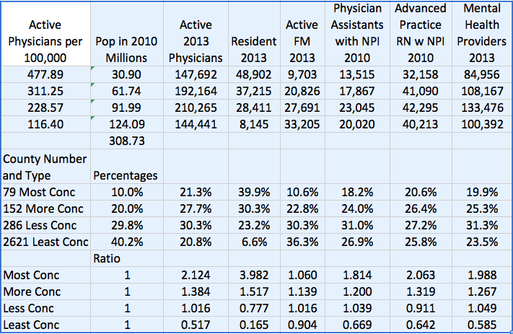

This is an improvement compared to rural coding which is about concentrations of people that can ignore concentrations of workforce. Also I find that what is indicated about rural health is also present in this 40% most behind with 75% of the rural population (40 million) and 32% of the urban population or 90 million. This 90 million is by far the fastest growing and has no recognition or advocacy group.

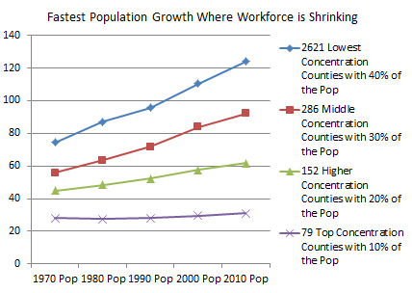

Two populations in America are increasing fastest relative to health care. One is the population in counties without a hospital as more counties are added and tend to be higher in population levels since the 1980s and DRGs/cost cutting. The second is lowest workforce concentration counties. Within these counties there is a stagnant rural component and a fastest growing urban segment – increasing faster than the blue line show.

These 2621 counties have long had deficits of workforce but also represent lower indicators across many other health, behavior, workforce, social determinant, and support areas.

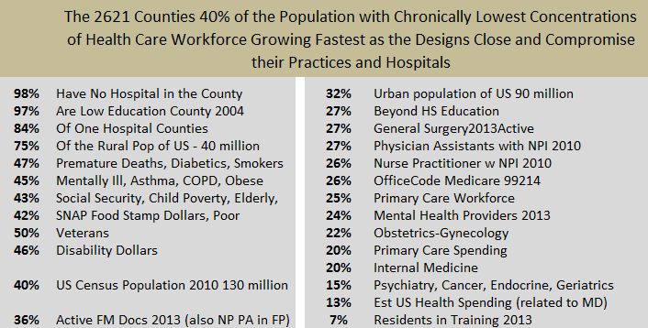

Only family practice positions filled by NP PA DO and MD have equitable distribution with 36% found in this 40% of the US population. But the designs continue to push all four into ever lower proportions of family practice and primary care. Some of this is due to massive overexpansion of NP PA DO and MD.

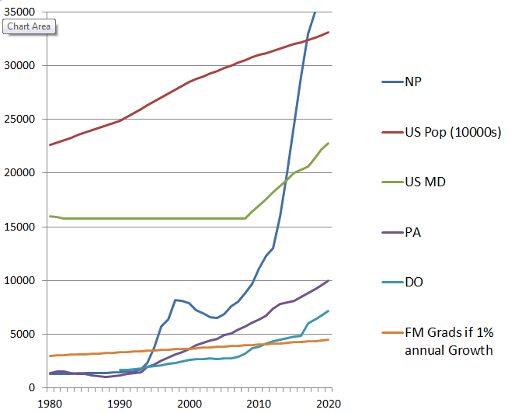

And the expansions are not helping out in primary care which has remained flat lined in primary care spending and workforce.

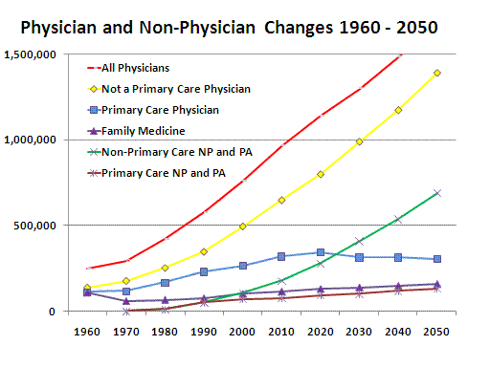

Is it possible for expansions of health care professional graduates to address shortages of generalists and general specialists across 40% of the US population with half enough primary care, mental health, women's health, and basic surgical workforce chronically?

NP graduates have been increasing at 6% a year, doubling each 12 years since the 1990s. PA graduates and osteopathic graduates have doubled each 14 years with a 5% annual increase. US MD has been increasing by 3 to 4% a year since 2003. There is no sign that deficits have been addressed.

The PA and DO contributions to primary care have been cut in half with each doubling of annual graduates for no gain. US MD contributions to primary care have declined by class year despite expansions.

Nebraska and Kansas have had superior pipelines that document 10 - 12 times instate practice location where needed - and yet the deficits remain.

It appears that training interventions cannot resolve deficits of workforce. The concentrations of elderly, poor, and worst employers in these counties suggests that deficits of workforce are shaped and maintained by the worst Medicaid, Medicare, and private health plans concentrated in these counties.

I want some recognition of the limitation of the financial design as shaping deficits of workforce. With only 5 to 6% of spending, primary care is unable to address deficits. In 2008 this translated to about 38 billion dollars for primary care in 2621 counties lowest in health care workforce with 40% of the US population. Since that time revenue has been flat, usual costs of delivery have gone up, and micromanagement types have increased and have cost more for each, especially in deficit areas. Medicare data from 2001 indicates 15% lower office payments in these counties with progressively lower payments as health care workforce levels decrease.

The evidence can be used to point out to health care leaders that a financial design change is the only way to address half enough generalists and general specialists for half of the nation. This is because the 40% in 2621 counties lowest in health care workforce should reach 50% of the US population by 2060 given fastest and steady rates of growth for the past 50 years. Also hospitals and practices have been stagnant to declining in these counties that are clearly growing fastest in population numbers, demand, and complexity.

Robert C. Bowman, MD

30 years of teaching, delivering, and researching Basic Health Access

Databases including numerous county and workforce characteristics from the County Rankings, Area Resource File, and AMA Masterfile